Comparative study on the effect of leucine and citric acid on calcium carbonate precipitation

Giuseppe Mazziotti di Celso¹, Marina Prisciandaro^{2*}, Despina Karatza³,
Dino Musmarra³, Amedeo Lancia⁴
1 University of Teramo, Faculty of Bioscience, Agri-Food and Environmental Technologies, 64100 Teramo, Italy;
2 University of L’Aquila, Dept. of Industrial and Information Engineering and of Economics, 67100 L’Aquila, Italy;
3 University della Campania Luigi Vanvitelli, Dept. of Engineering, 81031, Aversa (CE), Italy;
4 University Federico II of Naples, Dept. of Chemical, Materials and Production Engineering, 80125, Napoli, Italy
*Corresponding author E-Mail: marina.prisciandaro@univaq.it
1.Introduction
This paper is concerned on the study of crystallization of calcium carbonate, when leucine – a green additive – is added in solution as an additive. The action of leucine of influencing calcium carbonate precipitation kinetic is particularly interesting since CaCO₃ is a so valuable product that it is worthy to recover from industrial liquid wastes (e.g. desalination brines), in the circular economy approach. An example is the post-distillation liquid from Solvay Process (production of sodium carbonate, soda-ash), that is a Ca-rich waste; if not correctly disposed of, this waste is responsible for the strong salinity of nearby groundwater with calcium chloride pollution of natural water reservoirs and soil [1]. Another example of wastes from which calcium carbonate can be recovered are brines: this is gaining increasing interest in scientific literature, also because this method limits CO₂ emissions or removes CO₂ from desalination plants [2].
In any case, either carbonate is a product of the process or a scale to be avoided, appropriate additives, under particular experimental conditions, allow to produce CaCO₃ with the desired characteristics, such as purity, water content, particle size and shape and polymorphic form [3].
Experimental runs have been performed in a laboratory scale plant at room temperature, by adding CaCl₂2H₂O and NaHCO₃ as reagents, with a supersaturation range which spams from 2 to 60 mol/m³, using two different leucine concentration values (0.520 x 10⁻³ and 1.041 x 10⁻³ mol/l). Results obtained have been compared with previous published ones, carried out with no additive and with citric acid in solution. From the measurements of induction times for calcium carbonate nucleation, it was established that in solution the leucine, far from being a retardant, favours the precipitation of calcium carbonate, so it can be considered a promoter in calcium carbonate crystallization and this behaviour enhances when raising its concentration in solution.
2. Methods
Experimental apparatus is a laboratory scale plant, provided with a jacketed stirred reactor and an optical device. It is sketched in Figure 1, while a detailed description of the apparatus and the related optical technique used for the measurement of the induction time for nucleation is available elsewhere [4].
To prepare the calcium carbonate supersaturated solution to fill in the stirring reactor, three reagents have been mixed together with clear distillate water: calcium chloride dihydrate (CaCl₂2H₂O), sodium hydrogen carbonate (NaHCO₃) and L-leucine. EDTA titrimetric method was used to standardized all Ca²⁺ ions concentration as CaCO₃.
Before filling in the reactor, the solution was passed through a suitable filter, to separate possible undesired materials. All experimental runs have been performed at room temperature (T=25°C). Different values of CaCl₂2H2O and NaHCO₃ have been used, ranging from 2 to 60 mol/m3, while two concentrations of leucine 0.520 x 10⁻³ and 1.041 x 10⁻³ mol/l have been selected.
Experimental runs have been carried out at room temperature (T=25°C), with supersaturation ratio values ranging from 2 to 120.
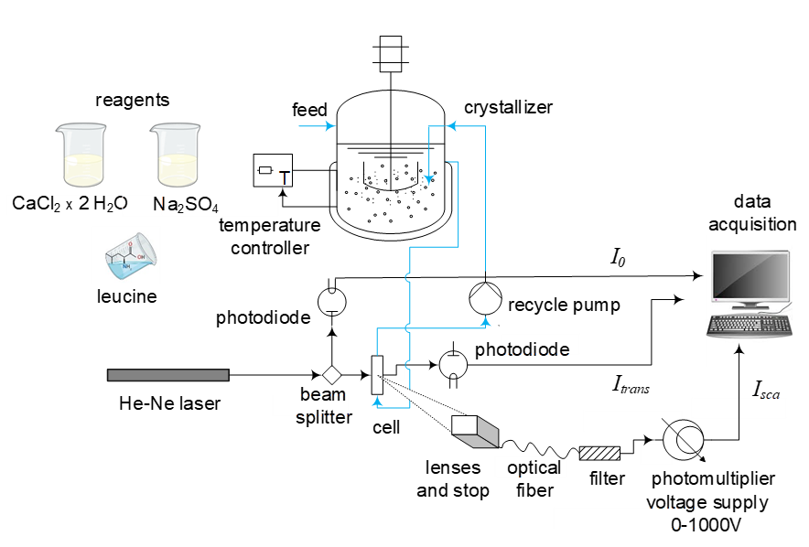
Figure 1. Experimental apparatus
3. Results and discussion
To study the effect of leucine addition on calcium carbonate nucleation, two experimental series for the induction time measurement have been performed at different leucine concentrations, keeping the temperature constant at T=25°C and varying the supersaturation ratio S. The first experimental series has been carried out at a leucine concentration (c_{LEU}) equal to 0.520 x 10⁻³ M, the second one at c_{LEU} = 1.041 x 10⁻³ M. The experiments are reported in the following Figure 2, where induction times are plotted as a function of supersaturation ratios for two leucine levels.
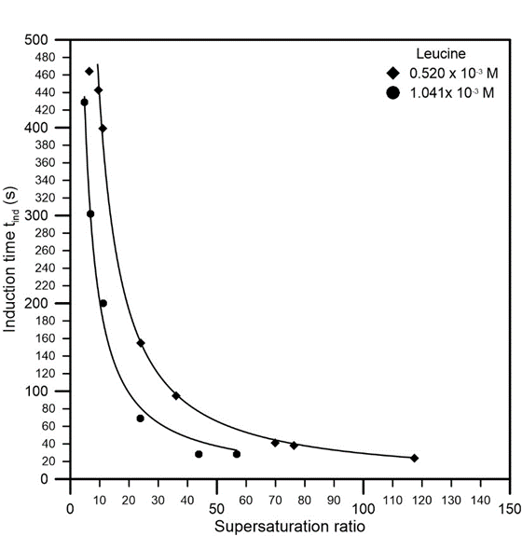
Figure 2. Induction time for CaCO₃ nucleation as a function of supersaturation ratio at different leucine concentrations.
As can be observed, for each curve at a fixed leucine concentration, the induction times decrease with increasing the supersaturation ratio. This is expected, since a higher ion concentration in solution results in a faster solid phase formation [5]. With increasing leucine concentration, passing from 0.520 x 10⁻³ M (rhombuses) to 1.041 x 10⁻³ M (circles), the induction times decrease and the curve moves downwards. Leucine seems to behave as a promoter for CaCO₃ crystallization. This behavior is likely due to the fact that when leucine is added in solution, the distance between the equilibrium and the metastable curves decreases, reducing the so-called metastable zone. This is an advantage if the target is to recover calcium carbonate with specific characteristics in terms of particle size, purity, shape and polymorphic form.
The promotion for CaCO₃ crystallization can be enhanced, as shown by the curves reported in Figure 2, if higher leucine concentration is added to the solution, which leads to lower induction times at the same supersaturation ratio.
Experimental results showed in Figure 2 have been compared with those obtained by the same research group in the absence of any additive [6-7] and in the presence of citric acid, which acts as a retardand for calcium carbonate nucleation [8-9]. This comparison in shown in Figure 3.
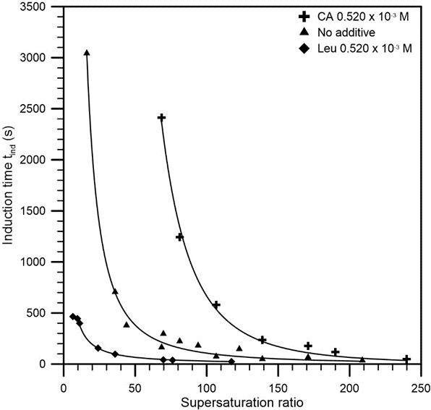
Figure 3. Induction time for CaCO₃ nucleation as a function of supersaturation ratio with additives (citric acid and leucine) and without any additive.
The figure shows the t_{ind} values measured in presence of citric acid (crosses) are higher, while t_{ind} values measured in presence of leucine (rhombuses), at the same concentration in solution, are lower than the induction times values obtained in the absence of any additives (triangles). This confirms the capacity of leucine to act as a promoter for calcium carbonate nucleation.
4. Conclusions
In this paper, the effect of leucine on the induction time of calcium carbonate crystallization has been studied. Two different concentrations of leucine in solution have been investigated, and the experimental runs, compared with previously published results with no additive and with citric acid in solution, have showed that leucine is a promoter for CaCO₃ precipitation and this behavior increases, if its concentration grows from 0.520 x 10⁻³ M to 1.041 x 10⁻³ M.
References
[1] R. Chang, S. Kim, S. Lee, S. Choi, M. Kim, Y. Park, Frontiers in Energy Research.
[2] J.H. Bang, Y. Yoo, S.W. Lee, K. Song, S. Chae, Minerals 7 (2017) 207.
[3] A. Declet, E. Reyes, O.M. Suarez, Reviews on Advanced Materials Science 44 (2016) 87-107.
[4] A. Lancia, D. Musmarra, M. Prisciandaro, AIChE Journal 45 (1999) 390-397.
[5] J.W. Mullin, Cristallyzation, forth ed., Butterworth-Heinemann Ltd., Oxford, 2001.
[6] G. Mazziotti di Celso, M. Prisciandaro, D. Karatza, A. Lancia, D. Musmarra, Canadian Journal of Chemical Engineering 95 (2017) 1671-1675.
[7] G. Mazziotti di Celso, M. Prisciandaro, D. Karatza, A. Lancia, D. Musmarra, Desalination and Water Treatmen 69 (2017) 173-177.
[8] K.J. Wada, A.C. Ramuson, Colloid Interface Science 282 (2005) 359-369.
[9] M.M. Reddy, G.H. Nancollas, Desalination 12 (1973) 61-73.

